**Business Proposal: CampusTrail — All‑in‑One Campus Travel Hub**

**Prepared for: E‑commerce (Term IV), IIM Kashipur**Prepared by: CampusTrail Project Team  
Date: September 07, 2025  
Version: v3.1 (Diagrams Edition)

# Section 2 — Product/Service Information: Diagrams

## 2.3.0 Generic Rental Flow



**Download SVG:** /mnt/data/2.3.0_Generic_Rental_Flow.svg

## 2.3.1 Fest DSLR Rental



**Download SVG:** /mnt/data/2.3.1_Fest_DSLR_Rental.svg

## 2.3.2 Trekking Group Formation



**Download SVG:** /mnt/data/2.3.2_Trekking_Group_Formation.svg

## 2.3.3 Last-Minute Tripod



**Download SVG:** /mnt/data/2.3.3_Last_Minute_Tripod.svg

## 2.3.4 Club Gear Pool



**Download SVG:** /mnt/data/2.3.4_Club_Gear_Pool.svg

## 2.3.5 Damage Dispute Resolution

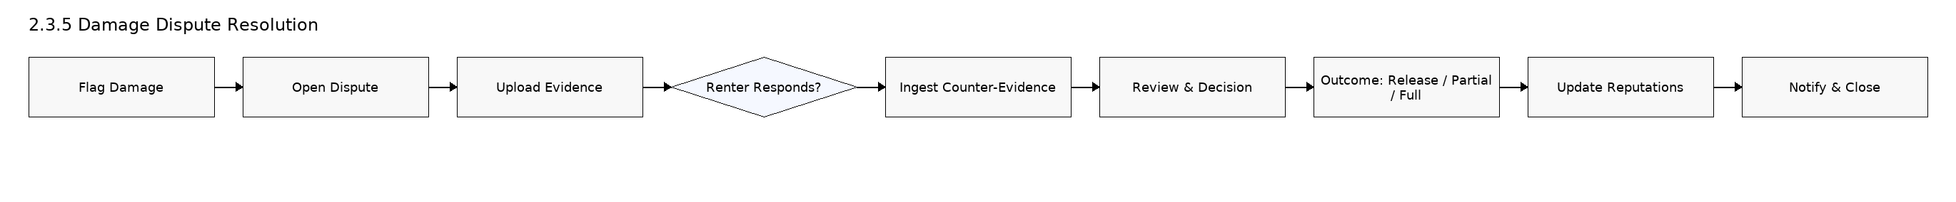

**Download SVG:** /mnt/data/2.3.5_Damage_Dispute_Resolution.svg

## 2.4.1 Deposit Hold/Capture/Release



**Download SVG:** /mnt/data/2.4.1_Deposit_Flow.svg

## 2.4.2 Dispute Resolution Flow



**Download SVG:** /mnt/data/2.4.2_Dispute_Resolution_Flow.svg

# Appendix — Mermaid Source (for reference)

All diagrams are also provided as Mermaid code blocks in: **/mnt/data/CampusTrail_Diagrams_Mermaid.md**